MJC 2010 JC2 Preliminary Examinations Paper 2 Suggested Answers

1(a) Fe²⁺ is stabilised in an acidic medium
OR
To prevent oxidation of Fe²⁺ to Fe³⁺

(b) 6Fe²⁺ + Cr₂O₇²⁻ + 14H⁺ → 6Fe³⁺ + 2Cr³⁺ + 7H₂O

(c) No. of mol of Cr₂O₇²⁻ used = 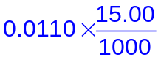
= 1.65 × 10⁻⁴
6Fe²⁺ ≡ Cr₂O₇²⁻

No. of mol of Fe²⁺ present in 25.0 cm³ = 6 × 1.65 × 10⁻⁴
= 9.91 × 10⁻⁴

No. of mol of Fe²⁺ present in 250 cm³ = 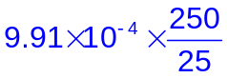
= 9.91 × 10⁻³

Mass of iron tablet (which contains FeSO₄) = 9.91 × 10⁻³ × (55.8+32.1+4(16.0))
= 1.51 g

(d) 1) Add Zn powder to the beaker containing the 250 cm³ solution of Fe²⁺/Fe³⁺ ions with stirring until no more Zn dissolves.
2) Filter the mixture using a filter funnel and collect the filtrate containing Fe²⁺ ions.
3) Pipette 25.0 cm³ of the Fe²⁺ solution (filtrate) into a conical flask and to it, add 1 cm³ of N-phenylanthranilic acid using a 10 cm³ measuring cylinder / graduated dropper.
4) Fill a burette with the given standard K₂Cr₂O₇ solution and note the initial reading on the burette.
5) Titrate the Fe²⁺ solution in the conical flask until the solution turns (from pale green to yellow to) violet; note the final reading on the burette.
6) Repeat the titration (steps 3 – 5) for consistent results (ie. titre values are within ±0.10 cm³ of each other).
Marking points
Procedure should include appropriate apparatus commonly found in a college laboratory:
- Addition of excess Zn powder into Fe²⁺/Fe³⁺ solution until no more Zn dissolves
- Filtration and collection of filtrate
- Proper preparation of aliquot
- Use of correct volume of indicator added
- Titration of aliquot against standard K₂Cr₂O₇ with end-point colour change to violet noted
- Initial and final burette readings noted with repeat of titration for consistent results

(e) No. of mol of Fe³⁺ present in 250 cm³ = p - q

No. of mol of Fe³⁺ present in sample = 2 × (p – q)

Mass of Fe³⁺ in actual sample = 2(p – q) × 55.8

Mass of oxidised iron tablet (containing FeSO₄ + Fe₂(SO4)₃)
= (2q × 151.9) + [½ × 2(p – q) × 399.9]
= 399.9p – 96.1q

Percentage by mass of iron(III) in sample = 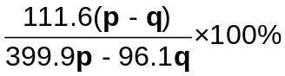
= 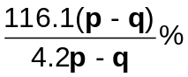

(f) Add a known mass of excess Zn powder to the solution containing Fe²⁺/Fe³⁺ ions.

Filter the resultant solution, recover and dry the residue containing the unreacted Zn powder.

The difference in mass of Zn can be used to calculate the no. of mol of Fe³⁺ present.

Alternative test: Iodometric titration (Fe³⁺ / I⁻)

2 (a) (i) MgCl₂ has a giant ionic lattice structure held by strong electrostatic forces of attraction between the oppositely charged Mg²⁺ and Cl⁻ ions. A large amount of energy is required to overcome the strong electrostatic forces of attraction, hence the melting point is high.
Aluminium chloride has a simple molecular structure.
The molecules are non-polar and held by which can be easily broken during melting weak induced dipole-induced dipole attractions/ Van der Waal’s forces of attraction. A small amount of energy is required to overcome the weaker forces of attraction between the molecules, hence the melting point is low.
- Al₂Cl₆ undergoes both hydration and hydrolysis when dissolved in water. The high charge density of hydrated Al³⁺ ion enables it to attract electrons away from one of its surrounding water molecules, thereby polarising and weakening the O-H bond to a greater extent which results in the release of a proton pH = 3.0

AlCl₃ + 6H₂O → [Al(H₂O)₆]³⁺ + 3Cl⁻
[Al(H₂O)₆]³⁺ [Al(H₂O)₅(OH)]²⁺ + H⁺
PCl₅ undergoes complete hydrolysis to form a strongly acidic solution with pH=1.0/2.0
PCl₅ + 4 H₂O → H₃PO₄ + 5 HCl
(b) (i) 2nd and 3rd electrons occupy the same quantum shell while 3rd and 4th electrons are removed from the different quantum shell.
(ii) N → N⁺ + e
1s²2s²2p⁶3s²3p⁴ 1s²2s²2p⁶3s²3p³
M → M⁺ + e
1s²2s²2p⁶3s²3p³ 1s²2s²2p⁶3s²3p²
OR
Element N is Group VI and Element M is Group V.
There is inter-electron repulsion between the paired electrons in the 3p orbital of element N.
Hence less energy is required to remove one valence 3p electron from N.
⇒ 1st ionisation energy of M > N.
(iii) M, being in Period 3, has empty and energetically accessible d orbitals to expand the octet configuration. Hence MO₄³⁻ can exist.

T, being in Period 2, does not have empty and energetically accessible d orbitals to accommodate the extra electrons and cannot expand the octet configuration. Hence TO₄³⁻ cannot exist.

(c) (i) 2 NOCl (g) 2 NO (g) + Cl₂ (g)
Initial moles 1 0 0
∆ in moles - 0.4 + 0.4 + 0.2
Eqm moles 0.6 0.4 0.2
K_{p} = 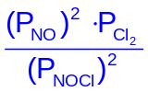
= 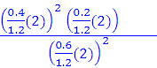
= 0.148 atm

(ii) The forward reaction is endothermic.

At a higher temperature, K_{p} value is larger, which means that more products are formed. Hence by Le Chatelier’s Principle, the equilibrium position should shift right towards the endothermic reaction to lower the temperature by absorbing the heat.

- When the total pressure is halved, by Le Chatelier’s Principle, the equilibrium position will shift right to produce more number of moles of gas molecules to increase pressure. The mass of the mixture remains constant, so since the no of moles of gas molecules increases, the apparent molar mass of the mixture decreases.

3(a) (i)
HCl (100 K)
HF (100 K)
PV/RT
HCl (400 K)

1.0
Ideal Gas

P
- HF is less ideal than HCl as HF has stronger intermolecular hydrogen bonding whereas HCl has weaker intermolecular Van der Waals forces of attraction.

(iii) At high temperature, there are negligible forces of attraction between the gas particles.
Hence, HCl gas will deviate less from ideal gas behaviour.

- (i) Initiation stage
Ultraviolet light
Cl₂ 2 Cl•
Propagation stage
•
CH₃CH₂CH₃ + Cl• CH₃CHCH₃ + HCl
CH₃CHCH₃ + Cl₂ CH₃CH(Cl)CH₃ + Cl•
•
Termination stage
2 Cl • Cl₂
•
CH₃CHCH₃ + Cl • CH₃CH(Cl)CH₃
•
•
CH₃CHCH₃ + CH₃CHCH₃ CH₃CH(CH₃)CH(CH₃)CH₃ or C₆H₁₄
- Condition of heat or uv light applies only in initiation step as chlorine free radicals are regenerated in propagation stage to keep reaction going.

- (i) 4Br₂ + S₂O₃²⁻ + 5H₂O → 2SO₄²⁻ + 10H⁺ + 8Br ⁻
(ii) No. of moles of S₂O₃²⁻ = 30/1000 x 0.100
= 0.00300 mol
S₂O₃²⁻ ≡ 4Br₂ ≡ 6 SiF₄
No. of moles of SiF₄ = 6 x 0.003
= 0.018
Mass of SiF₄ = 0.018 x (28.1 +19.0 x 4)
= 1.9 g
- Disproportionation
3 Br₂ + 6 OH- → 5Br- + BrO₃- + 3 H₂O

4(a) (i) (1) Cis-trans / geometric isomerism
(2) No of isomers present = 3
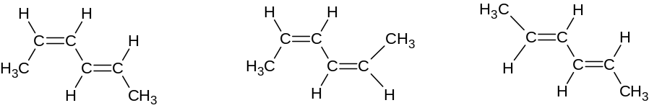
cis-trans cis-cis trans-trans

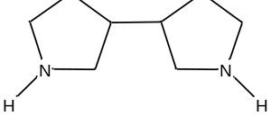

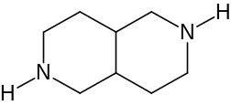

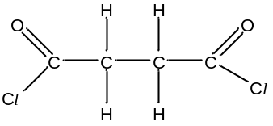
C
OR
D
E
C
C
C
C
N
H
C
N
H
H
H
C
H
3
C
H
H
C
H
3

(iii)
 | Reagents | Conditions
Stage I | 1. aq I₂ and aq. NaOH  2. dilute or aq HCl or H₂SO₄ | 1. Heat  2. r.t.p.
Stage II | PCl ₅ (Or SOCl₂) | r.t.p. (or Heat for SOCl₂)
Stage III | HO(CH₂)₂OH | r.t.p.
Stage IV | Ethanolic / Alcoholic KCN | Heat
Stage V | (Limited) Cl ₂(g) | uv light

- B has a plane of symmetry and has superimposible mirror images.
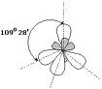
(c) sp³ hybridisation
109.5º

5(a) (i) Analysis:
Hydrolysis of peptide Y → gain in 1 H₂O for every peptide bond broken.
No. of peptide bonds broken = 6
M_{r} of peptide Y = 2 x 181 + 3 x 165 + 174 x 2 - 6 x 18
= 1097
- At low concentration of peptide Y,
- Rate of reaction increases linearly as active sites of the enzyme are not fully occupied
- Reaction is approximately first order wrt the concentration of peptide Y.
However, at high concentration of peptide Y,
- Rate of reaction is constant
- Rate is independent of concentration of peptide Y as all active sites occupied
- Reaction is zero order wrt the concentration of peptide Y.

(b) (i) Any 2 of the following: Serine, Aspartic acid, Lysine, Histidine.
This is due to the formation of hydrogen bonding between the amino acids and water molecules.
- At low pH,
- Excess H⁺ will react with basic amine group in histidine/lysine of the chymotrypsin.
- Hence, low pH will disrupt ionic bonds and hydrogen bonds formed between basic amine group in histidine/lysine and the acidic carboxylic group in aspartic acid which are critical to the tertiary and quaternary structure of the enzyme.
- This will thus lead to changes in enzyme shape and shape of active site and hence loss of enzyme activity and denaturation.

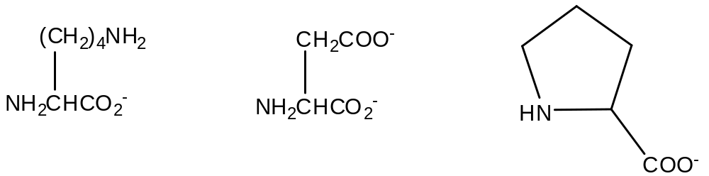
(c)

6(a) (i) Unlike all other Group II elements, beryllium oxide is amphoteric and it reacts with an acid and base in the same way as aluminium.

Reaction with HCl: BeO + 2 H⁺ → Be²⁺ + H₂O
Reaction with NaOH: BeO + 2 OH⁻ + H₂O → [Be(OH)₄]²⁻

- Al₄C₃ + 6 H₂O → 2 Al₂O₃ + 3 CH₄

(b) (i) Down the group,
    - ionic size of cation increases
    - charge density of cation decreases
    - polarising power of cation decreases
    - polarising effect on CO₃²⁻ anion decreases or the ability of the cation to distort the anion charge cloud of CO₃²⁻ decreases
    - thermal stability increases hence decomposition temperature increases

(ii) Be²⁺ behaves like Al³⁺ where it has a very high charge density that polarises CO₃²⁻ very easily compared to the rest of the Group II metal ions.
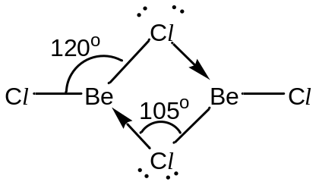
(c)

(d) (i) Be in BeF₂ is electron deficient and is able to accept 2 dative bonds from the fluoride ions to fulfill its stable octet configuration.

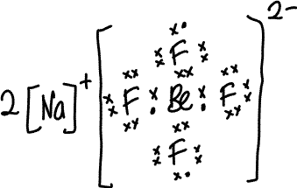
(ii)

END OF PAPER

